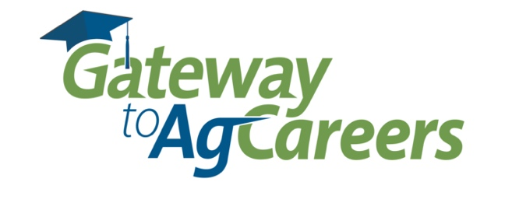
Gateway to Ag Careers (GTAC) – 2022 Grant Application
The following information will be used by the AgGateway Conference Committee in their selection process for the Gateway to Ag Career grants. All submissions must be received no later than September 15, 2022. We encourage all students to apply for this program; however, only the top submissions will be awarded grants.
Please send all each submission via e-mail to GTAC@AgGateway.org
Nominating Advisor/Sponsor - Please include a brief paragraph explaining why you have nominated this student (on page 2).
Nominating University/College: _____________________________________________________
Nominating Advisor/Sponsor’s Name: ____________________________________________________
Sponsor’s Contact Information: __________________________________________________________________
(Address) (City) (ST) (Zip)

________________________ __________________________________________________
(Sponsor’s Phone # ) (Sponsor’s e-mail Address)

Students - Please include a one-page essay providing your background information and explaining what you hope to gain by participating in the AgGateway conference (on page 3).
Student’s Name: ______________________________________________________
Student’s Contact Information: _______________________________________________________________
(Address) (City) (ST) (Zip)

_____________________________ ________________________________
(Student’s Phone) (Student’s email Address)

Declared Major: ________________________________________________________

Declared Minor: ________________________________________________________

Class Level: ____________________________________________________________
Nominating Advisor/Sponsor - Please include a brief paragraph explaining why you have nominated this student.

Students - Please include an essay (one-page or less) providing your background information and explaining what you hope to gain by participating in the AgGateway conference.

